Maandkalenders schooljaar 2024-2025



Algemene maandkalender







september

|  |  |  |  |  |  |  |
| --- | --- | --- | --- | --- | --- | --- |
| **Maandag** | **Dinsdag** | **Woensdag** | **Donderdag** | **Vrijdag** | **Zaterdag** | **Zondag** |
|  |  |  |  |  |  | 1 |
| 2  Eerste schooldag | 3 | 4 | 5 | 6 | 7 | 8 |
| 9 | 10 | 11 | 12 | 13 | 14 | 15 |
| 16 | 17 | 18 | 19 | 20 | 21  herfst | 22 |
| 23 | 24 | 25 | 26 | 27 | 28 | 29 |
| 30 |  |  |  |  |  |  |

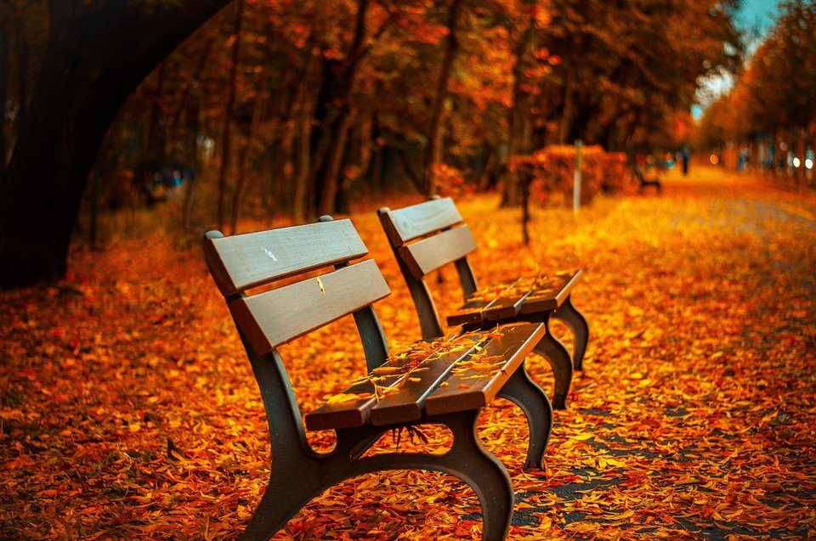

oktober

|  |  |  |  |  |  |  |
| --- | --- | --- | --- | --- | --- | --- |
| **Maandag** | **Dinsdag** | **Woensdag** | **Donderdag** | **Vrijdag** | **Zaterdag** | **Zondag** |
|  | 1 | 2 | 3 | 4 | 5  Dag v/d leerkracht | 6 |
| 7 | 8 | 9 | 10 | 11 | 12 | 13 |
| 14 | 15 | 16 | 17 | 18 | 19 | 20 |
| 21 | 22 | 23 | 24 | 25 | 26 | 27 |
| 28 | 29 | 30 | 31  Halloween |  |  |  |

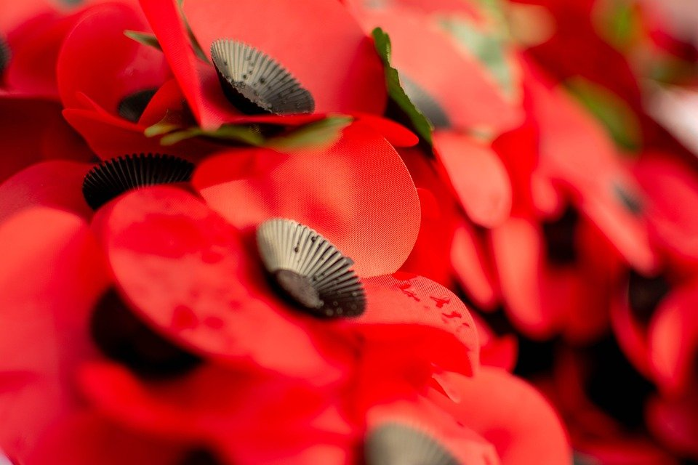

november

|  |  |  |  |  |  |  |
| --- | --- | --- | --- | --- | --- | --- |
| **Maandag** | **Dinsdag** | **Woensdag** | **Donderdag** | **Vrijdag** | **Zaterdag** | **Zondag** |
|  |  |  |  | 1 | 2 | 3 |
| 4 | 5 | 6 | 7 | 8 | 9 | 10 |
| 11  Wapenstilstand | 12 | 13 | 14 | 15 | 16 | 17 |
| 18 | 19 | 20 | 21 | 22 | 23 | 24 |
| 25 | 26 | 27 | 28 | 29 | 30 |  |
|  | 29 | 30 | Gratis foto's van Kerstballen |  |  | december |

|  |  |  |  |  |  |  |
| --- | --- | --- | --- | --- | --- | --- |
| **Maandag** | **Dinsdag** | **Woensdag** | **Donderdag** | **Vrijdag** | **Zaterdag** | **Zondag** |
|  |  |  |  |  |  | 1 |
| 2 | 3 | 4 | 5 | 6  Sinterklaas | 7 | 8 |
| 9 | 10 | 11 | 12 | 13 | 14 | 15 |
| 16 | 17 | 18 | 19 | 20 | 21  winter | 22 |
| 23 | 24  kerstavond | 25  Kerstmis | 26 | 27 | 28 | 29 |
| 30 | 31  oudejaarsavond |  |  |  |  |  |



januari

|  |  |  |  |  |  |  |
| --- | --- | --- | --- | --- | --- | --- |
| **Maandag** | **Dinsdag** | **Woensdag** | **Donderdag** | **Vrijdag** | **Zaterdag** | **Zondag** |
|  |  | 1  Nieuwjaar | 2 | 3 | 4 | 5 |
| 6 | 7 | 8 | 9 | 10 | 11 | 12 |
| 13 | 14 | 15 | 16 | 17 | 18 | 19 |
| 20 | 21 | 22 | 23 | 24 | 25 | 26 |
| 27 | 28 | 29 | 30 | 31  Dag v/d directeur |  |  |



februari

|  |  |  |  |  |  |  |
| --- | --- | --- | --- | --- | --- | --- |
| **Maandag** | **Dinsdag** | **Woensdag** | **Donderdag** | **Vrijdag** | **Zaterdag** | **Zondag** |
|  |  |  |  |  | 1 | 2 |
| 3 | 4 | 5 | 6 | 7 | 8 | 9 |
| 10 | 11 | 12 | 13 | 14  Valentijn | 15 | 16 |
| 17 | 18 | 19 | 20 | 21 | 22 | 23 |
| 24 | 25 | 26 | 27 | 28 |  |  |

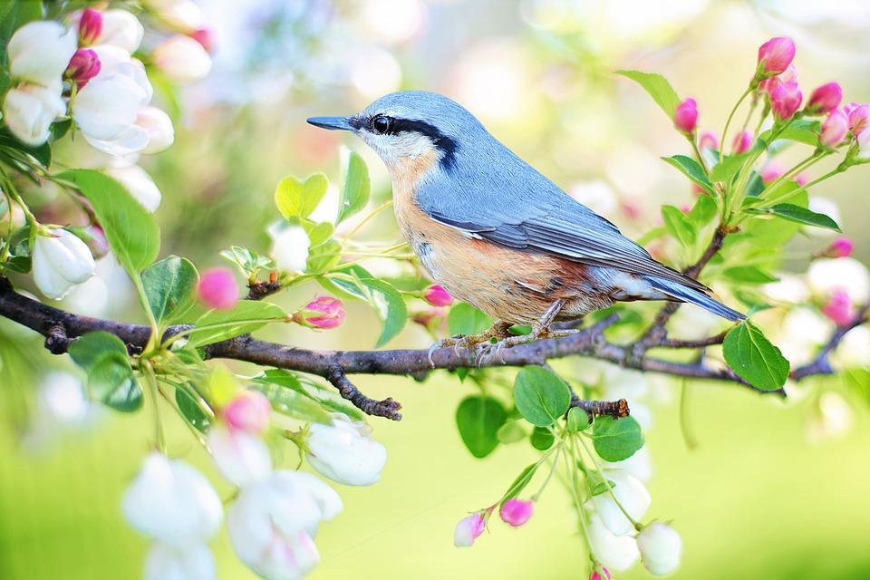

maart

|  |  |  |  |  |  |  |
| --- | --- | --- | --- | --- | --- | --- |
| **Maandag** | **Dinsdag** | **Woensdag** | **Donderdag** | **Vrijdag** | **Zaterdag** | **Zondag** |
|  |  |  |  |  | 1 | 2  Carnaval |
| 3 | 4 | 5 | 6 | 7 | 8 | 9 |
| 10 | 11 | 12 | 13 | 14 | 15 | 16 |
| 17 | 18 | 19 | 20 | 21  lente | 22 | 23 |
| 24 | 25 | 26 | 27 | 28 | 29 | 30 |
| 31 |  |  |  |  |  |  |



april

|  |  |  |  |  |  |  |
| --- | --- | --- | --- | --- | --- | --- |
| **Maandag** | **Dinsdag** | **Woensdag** | **Donderdag** | **Vrijdag** | **Zaterdag** | **Zondag** |
|  | 1 | 2 | 3 | 4 | 5 | 6 |
| 7 | 8 | 9 | 10 | 11 | 12 | 13 |
| 14 | 15 | 16 | 17  secretaressedag | 18 | 19 | 20  Pasen |
| 21  Paasmaandag | 22 | 23 | 24 | 25 | 26 | 27 |
| 28 | 29 | 30 |  |  |  |  |



mei

|  |  |  |  |  |  |  |  |
| --- | --- | --- | --- | --- | --- | --- | --- |
| **Maandag** | | **Dinsdag** | **Woensdag** | **Donderdag** | **Vrijdag** | **Zaterdag** | **Zondag** |
|  |  | |  | 1  Dag v/d arbeid | 2 | 3 | 4 |
| 5 | 6 | | 7 | 8 | 9 | 10 | 11  Moederdag |
| 12 | 13 | | 14 | 15 | 16 | 17 | 18 |
| 19 | 20 | | 21 | 22 | 23 | 24 | 25 |
| 26 | 27 | | 28 | 29  Hemelvaart | 30 | 31 |  |



juni

|  |  |  |  |  |  |  |
| --- | --- | --- | --- | --- | --- | --- |
| **Maandag** | **Dinsdag** | **Woensdag** | **Donderdag** | **Vrijdag** | **Zaterdag** | **Zondag** |
|  |  |  |  |  |  | 1 |
| 2 | 3 | 4 | 5 | 6 | 7 | 8  Vaderdag  Pinksteren |
| 9  Pinkstermaandag | 10 | 11 | 12 | 13 | 14 | 15 |
| 16 | 17 | 18 | 19 | 20 | 21  zomer | 22 |
| 23 | 24 | 25 | 26 | 27 | 28 | 29 |
| 30  laatste schooldag |  |  |  |  |  |  |

Alle afbeeldingen zijn afkomstig van Pixabay.com